

Politecnico di Milano

A.A. 2015-2016

Software Engineering 2: “myTaxiService”

Test Plan Document

Luiza Bentivoglio, Michele Cantarutti

22 January 2016

Summary

**1. INTRODUCTION ............................................................................................................4**

1.1 REVISION HISTORY ..........................................................................................................................4

1.2 PURPOSE AND SCOPE .....................................................................................................................4

1.3 LIST OF DEFINITIONS AND ABBREVIATIONS ..................................................................................4

1.4 LIST OF REFERENCE DOCUMENTS .................................................................................................5

**2. INTEGRATION STRATEGY ......................................................................................6**

2.1 ENTRY CRITERIA .............................................................................................................................6

2.2 ELEMENTS TO BE INTEGRATED ...................................................................................................6

2.3 INTEGRATION TESTING STRATEGY .............................................................................................7

2.4 SEQUENCE OF COMPONENT/FUNCTION INTEGRATION ............................................................7

**3. INDIVIDUAL STEPS AND TEST DESCRIPTION ..............................................10**

**4. TOOLS AND TEST EQUIPMENT REQUIRED ....................................................10**

**5. PROGRAM STUBS AND TEST DATA REQUIRED .............................................11**

**1. Introduction**

**1.1 REVISION HISTORY**

This is the first version of this document and no updates have been made yet. 21th January 2016.

**1.2 PURPOSE AND SCOPE**

The purpose of this document (ITPD) is to explain to the development team what to test, in which sequence, which tools are needed for testing, which stubs, drivers, oracles need to be developed and to describe the plans for testing the integration of the created components for the myTaxiService project. By integration, we mean the phase during which software modules are combined and tested as a group, and in fact, at this stage of our project we assume that all the modules of our project have been unit tested and therefore each one of them is working correctly individually. Therefore, the scope of this document is not focused on single modules but revolves around the system in the whole, considering all the modules together, and mostly testing whether all the components within assemblages interact correctly.

**1.3 LIST OF DEFINITIONS AND ABBREVIATIONS**

PASSENGER: a component on the client side, which represents a registered user, who is a customer of our service.

TAXI DRIVER: a component on the client side, which represents a taxi driver, which is a person who interacts with the system with the purpose of serving users.

CLIENT/USER: these two terms will often be used interchangeably and they’re

used to describe whoever uses the web application or the mobile application from the client’s side, thus passengers and taxi drivers.

REQUEST: a component that represents requests, which have been defined in our RASD and DD document.

RESERVATION: a component that represents reservations, which have been defined in our RASD and DD document.

DRIVER: a main program that accepts test data, passes such data to the component and prints relevant results.

ITPD: Integration Test Plan Document  
  
RASD: Requirement Analysis and Specification Document  
  
DD: Design Document

**1.4 LIST OF REFERENCE DOCUMENTS**

As references for this document we used:

* The project description, that has been provided to us
* Our RASD document
* Our Design document
* Integration test plan example, SpinGRID

**2. Integration Strategy**

**2.1 ENTRY CRITERIA**

Before the integration testing can start, we must verify (or assume, in this document) that all the modules have undergone unit-tests successfully. Moreover, we will assume that each module is code-complete, which means there are no missing features. Likewise, we will assume that the developers have yielded a complete documentation for each module, so as to provide support in understanding any possible problems that might arise during the testing of the interaction between multiple components.

**2.2 ELEMENTS TO BE INTEGRATED**

The figure below shows the main components that form the myTaxiService system. The arrows represent the order of integration. i.e. integration testing.

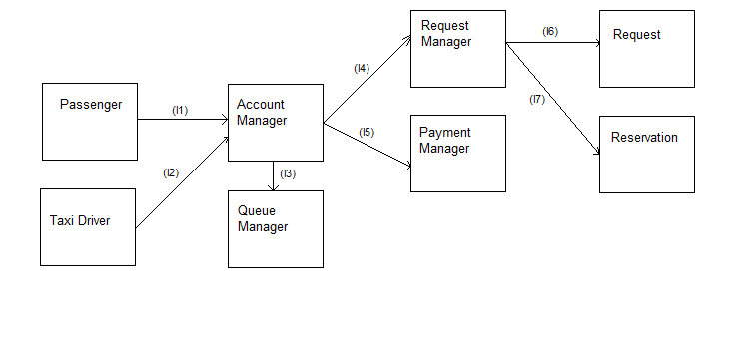**Integration Tests of the dispatcher-software**

|  |  |  |
| --- | --- | --- |
| **ID** | **Integration Test** | **Paragraphs** |
| I1 | Passenger -> Account Manager | 2.4.1 3.1 |
| I2 | Taxi Driver -> Account Manager | 2.4.2 3.1 |
| I3 | Account Manager -> Queue Manager | 2.4.3 3.2 |
| I4 | Account Manager -> Request Manager | 2.4.4 3.2 |
| I5 | Account Manager -> Payment Manager | 2.4.5 3.2 |
| I6 | Request Manager -> Request | 2.4.6 3.2 |
| I7 | Request Manager -> Reservation | 2.4.7 3.2 |

The picture below shows the interaction and the communication between the Account manager on the server and the client. By communication we mean the notifications that the server can potentially send to the users to notify them about something that has happened.

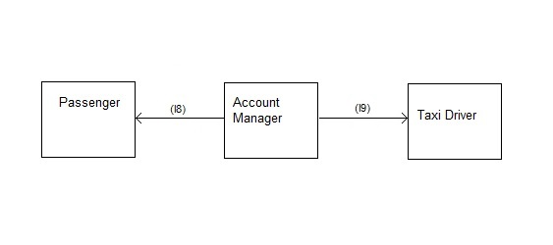

|  |  |  |
| --- | --- | --- |
| **ID** | **Integration Test** | **Paragraphs** |
| I1 | Account Manager -> Passenger | 2.4.8 3.1 |
| I2 | Account Manager -> Taxi Driver | 2.4.9 3.1 |

**2.3 INTEGRATION TESTING STRATEGY**

We intend to test the modules that make up our system by using a bottom-up approach. This means that the testing will start at the bottom level (so that we can grant that the basic parts of our system are working from the beginning) and then the integration testing will follow the unit testing (which we assume has already been carried out).

**2.4 SEQUENCE OF COMPONENT/FUNCTION INTEGRATION**

**2.4.1 Integration test case I1**

|  |  |
| --- | --- |
| Test Case Identifier | I1T1 |
| Test Item(s) | Passenger -> Account manager |
| Input Specifications | Create typical Passenger input |
| Output Specifications | Check if the correct functions are called in the Account manager |
| Environmental Needs | Passenger driver |

**2.4.2 Integration test case I2**

|  |  |
| --- | --- |
| Test Case Identifier | I1T2 |
| Test Item(s) | Taxi driver -> Account manager |
| Input Specifications | Create typical Taxi driver input |
| Output Specifications | Check if the correct functions are called in the Account manager |
| Environmental Needs | Taxi driver driver |

**2.4.3 Integration test case I3**

|  |  |
| --- | --- |
| Test Case Identifier | I2T1 |
| Test Item(s) | Account Manager -> Queue Manager |
| Input Specifications | Create typical Account Manager input |
| Output Specifications | Check if the correct functions are called in the Queue Manager |
| Environmental Needs | I1-I2 succeeded |

**2.4.4 Integration test case I4**

|  |  |
| --- | --- |
| Test Case Identifier | I3T1 |
| Test Item(s) | Account Manager -> Request Manager |
| Input Specifications | Create typical Account Manager input |
| Output Specifications | Check if the correct functions are called in the Request Manager |
| Environmental Needs | I1-I2 succeeded |

**2.4.5 Integration test case I5**

|  |  |
| --- | --- |
| Test Case Identifier | I4T1 |
| Test Item(s) | Account Manager -> Payment Manager |
| Input Specifications | Create typical Account Manager input |
| Output Specifications | Check if the correct functions are called in the Payment Manager |
| Environmental Needs | I3-I4 succeeded |

**2.4.6 Integration test case I6**

|  |  |
| --- | --- |
| Test Case Identifier | I5T1 |
| Test Item(s) | Request Manager -> Request |
| Input Specifications | Create typical Request Manager input |
| Output Specifications | Check if the correct functions are called in the Request Object |
| Environmental Needs | I4 succeeded |

**2.4.7 Integration test case I7**

|  |  |
| --- | --- |
| Test Case Identifier | I6T1 |
| Test Item(s) | Request Manager -> Reservation |
| Input Specifications | Create typical Request Manager input |
| Output Specifications | Check if the correct functions are called in the Reservation Object |
| Environmental Needs | I4 succeeded |

**2.4.8 Integration test case I8**

|  |  |
| --- | --- |
| Test Case Identifier | I7T1 |
| Test Item(s) | Account Manager -> Passenger |
| Input Specifications | Create typical Account Manager input |
| Output Specifications | Check if the correct functions are called in the Passenger Object |
| Environmental Needs | N/A |

**2.4.9 Integration test case I9**

|  |  |
| --- | --- |
| Test Case Identifier | I8T1 |
| Test Item(s) | Account Manager -> Taxi Driver |
| Input Specifications | Create typical Account Manager input |
| Output Specifications | Check if the correct functions are called in the Taxi Driver Object |
| Environmental Needs | N/A |

**3. Individual steps and test description**

**3.1 Integration test procedure TP1**

|  |  |
| --- | --- |
| **Test Procedure Identiﬁer** | **TP1** |
| **Purpose** | This test procedure veriﬁes whether the main software:  • can handle command-line input  • can handle passenger input  • can handle taxi driver input  • can output requested information to a passenger  • can output requested information to a taxi driver |
| **Procedure Steps** | Execute I6-I7 |

**3.2 Integration test procedure TP2**

|  |  |
| --- | --- |
| **Test Procedure Identiﬁer** | **TP2** |
| **Purpose** | This test procedure veriﬁes whether the notification software:  • can handle account manager input  • can output notifications to the passenger  • can output notifications to the taxi driver |
| **Procedure Steps** | Execute I8-19 |

**4. Tools and test equipment required**

These are the tools we deem necessary for the testing:

-Mockito, an open source testing framework for Java. The framework allows the creation of test double objects (mock objects) in automated unit tests;

-Jmeter, which can be used as a load testing tool for analyzing and measuring the performance of a variety of services;

- Arquillian; A test framework that can be used to perform testing inside a remote or embedded container, or deploy an archive to a container so the test can interact as a remote client.

**5. Program stubs and test data required**

Depending on the situation, different elements will be needed throughout the testing. For example, the first integration tests are carried out on the communication between the client side and the account manager on the server, and these tests will require a driver for each type of client ( passenger and taxi driver) to simulate the possible behaviors of the user. By driver we mean a main program that accepts test data and passes this test to the component to be tested and prints relevant results.

In other situations, for example those regarding the Queue Manager and the Request Manager, we will need test data to work on, thus a simulation of the database. The simulation of the database must represent the possible instances that might occur, for example there should be several passengers and taxi drivers to see how well the system can manage the queues and the requests that are being made.

In the case of the testing on the notification system, we will only need two stubs, one representing the server side and one representing the client side, so that we can test whether the notification functionalities work correctly while sending messages to the clients.